DSL – JOB DESCRIPTION
Job title: Loans Management Officer | Name of postholder:
Company: DSL Business Finance Ltd | Section (if applicable):
Reports to (job title): FUND MANAGER

Organisation chart (reporting lines above and below this job):
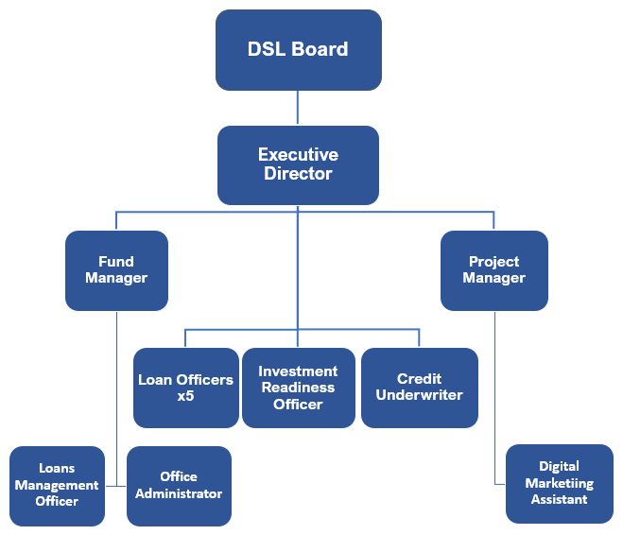
Job context:
DSL Business Finance Ltd is Scotland’s leading not-for-profit lender providing access to loan finance for Start-Ups, SMEs and Social Enterprises. Any surpluses made by the organisation are re-invested for lending rather than being distributed amongst shareholders. In addition to our lending activities we also manage funds on behalf of other organisations e.g. the Start Up Loans Company (SULCo) which is a British Business Bank/UK government initiative and Scottish Government.
Our objectives are:- to create opportunities for enterprise; grow existing businesses ; create jobs and strengthen the sustainability of local communities.

Job purpose:
The Loans Management Officer is responsible for monitoring client performance including collection of loan repayments, debt control and the provision of post–loan support. They will also be responsible for producing reports for our Partners, Funders and Stakeholders in relation to debt management and will work closely with the Fund Manager.

Assignment and review of work:
Duties are determined by the Fund Manager in consultation with the Executive Director. Annual formal reviews of work objectives will take place with ongoing informal overview meetings as required in line with normal business practice.

Key result areas (5-10 statements):

For DSL loans and loans managed on behalf of third parties:
- Loan Management for new & existing loan customers:
  - Ensuring all new direct debit mandates are implemented accurately and on time.
  - Managing all loan repayments via BACS and monthly bank statements.
  - Ensuring compliance with Consumer Credit Act (CCA) by providing payment information to clients including Annual Statements and Notices of Arrears.
- Management of any loan arrears:
  - Assessing and agreeing repayment plans with clients and putting in place any variation to loan agreements. Client visits may occasionally be required.
  - Ensuring that the DSL Board has a clear line of sight of the loan portfolio at any given time by producing appropriate reports and seeking authority for proposed write-offs etc
- Implementation of DSL debt recovery procedures:
  - Undertaking in a timely manner in accordance with DSL policy & procedures
  - Adhering to and being compliant with FCA Regulations
- Third party loan funds managed by DSL:
  - Liaising with DSL’s Funders, Partners and Stakeholders as required
- Establishing New third party loan funds
- Assist with the assignation of any new third party loan funds and any other aspects that may be identified in consultation with the Fund Manager.

Compliance, Policy and Procedures
- Adhering to British Business Bank (BBB) compliance and administration requirements by ensuring DSL’s portal entries meet BBB’s legal requirements with particular reference to recoveries and guarantee premiums.
- Updating DSLs debt recovery policy and procedures in line with CCA regulations and other relevant legislation.
- Actively seeking to identify any appropriate changes and/or improvements to debt recording systems that can be implemented whilst continuing to ensure accuracy, confidentiality and maintaining adherence to legislative guidelines.

General Activities
- Undertaking any administration in support of the above by to ensure the loan portfolio is accurately and efficiently maintained.

Communications and working relationships (internal and external):

Internal

Fund Manager/Executive Director Assignment and progression of work
DSL Board of Directors Quarterly Reports
DSL Team Interactions as required .

External
Clients, Legal advisors Provision and exchange of information
Funders, Partners, Stakeholders Monthly/quarterly reports

Job requirements (qualities, skills, and experience)
Essential
- Experience of working in debt recovery/control.
- Proficient IT skills including data entry.
- Accuracy and attention to detail.
- Ability to work on own initiative as well as part of a team with minimal supervision.
- Ability to efficiently manage workload in a timeous manner.
- Flexible and positive attitude.
- Efficiency, organisation, consistency and a high level of diligence.

Desirable
- Experience of working in financial services and knowledge of Scottish legal system.
- Experience of a busy office and working in a small team.
- Good communication skills , both written and oral.
- Good telephone manner.
- Ability to interact with people from diverse backgrounds.

Signature of postholder: | Date:
Signature of manager: | Date:
Job description compiled by:  S McLean/S M Yuill | Date completed/revised:  April 2021

