DSL – JOB DESCRIPTION
Job title: CREDIT UNDERWRITER
Salary: £30k to £35k depending upon experience
Reports to: EXECUTIVE DIRECTOR

Organisation chart (reporting lines above and below this job):

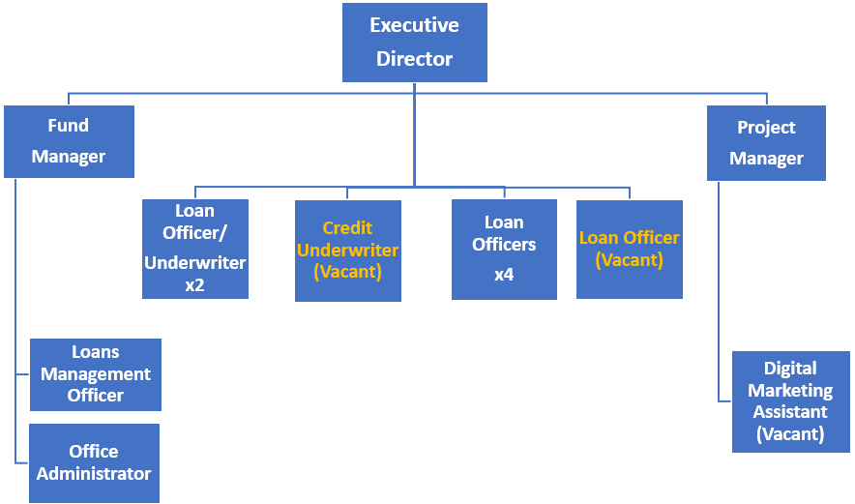
Job context:
DSL Business Finance is Scotland’s leading not-for-profit lender providing access to loan finance for SMEs. Any profits made by the organisation are re-invested for lending rather than being distributed amongst shareholders. In addition to our lending activities, we also manage funds for other organisations. Our business has grown steadily in recent times with several funds being delivered in the past 5 years. This has generated lending of £23m to 737 businesses.

DSL is the Regional Business Support Partner (BSP) for Scotland of the Start Up Loan Company. We aim to ensure that anyone wanting to start a business can do so, regardless of their economic or social background.

We have also recently been appointed by British Business Bank to deliver the Smaller Loans part of the Investment Fund for Scotland, the aim of which is to ensure Scotland’s SMEs are provided with access to Early Stage, Start Up, Growth or Expansion finance by way of loans from £25k - £100k.

Other loans funds are also delivered throughout Scotland.

Our objectives are to create opportunities for enterprise; grow existing businesses, create jobs, and strengthen the sustainability of local communities.

Job purpose:
The Credit Underwriter is responsible for reviewing and assessing loan applications submitted by the Loan Officer team, and ensuring applications received comply with scheme rules and are within policy when making credit decisions.

The post holder will ensure all internal and external risk/compliance protocols are followed and maintained, preparing accurate and concise assessments that provide a clear indication of the decision-making process to achieve a ‘right first time’ outcome.
Assignment and review of work:
Duties are determined by the Executive Director. There will be an annual appraisal with interim reviews of objectives as well as ongoing informal meetings as required in line with normal business practice. Priorities are set in line with business needs.
Key result areas (5-10 statements):

The role will include, but not be limited to, the following: -

As a Credit Underwriter you will be expected to: -
- Appraise Loan Officer applications submitted on behalf of clients seeking loans, undertaking affordability and viability analysis based on various financial and non-financial information to assess lending risk.
- Deliver timely credit decisions within documented credit policies and own underwriting authority, providing commercially sound recommendations, balancing risk, and supporting customer requirements.
- Assist with the day-to-day credit management and decision-making process.
- Work with other areas of the Business to ensure correct lending decisions and fair outcomes for customers.
- Deliver operational effectiveness and excellence within the business, achieving agreed KPI targets and objectives.
- Ensure strong lines of communication with all areas of the business are maintained and assist the team in achieving SLA’s.

Development/Support Activities will include: -
- Assisting and supporting the DSL team to deliver lending upskilling where appropriate.
- Developing relationships with funding partners to ensure any changes in lending policies/risk protocols/new initiatives are understood and delivered to the DSL team in a timely manner.
- Attending new funding launches and similar events as apt for the role.
- Identifying improvements to policy and procedures.
- Signposting other agencies to Loan Officers where further client help is required.

Corporate Activities will include: -
- Assisting with the organisation of DSL client and partner events.
- Representing the company at relevant events.
Responsibility for resources (direct or indirect):

Number of people: N/A
Budgets: N/A
Finance: N/A
IT: Using and updating systems and processes as appropriate.

Communications and working relationships (internal and external):

Internal
Executive Director, DSL Team | Assignment and progression of work.

External
Professionals, Business Advisers and Other funding organisations | Provision and exchange of information to promote the various loan funds.

Job requirements (qualifications, skills, and experience - for job, not of specific job holder):

Essential
- Personally organised, diligent with an eye for attention to detail.
- An understanding of the SME market
- Strong analytical skills with ability to document findings and make recommendations.
- Excellent communicator both verbal and written.
- Ability to work independently and as part of a team being able to take initiative as circumstances require.
- Competent IT Skills.

Desirable
- Business Plan assessment skills
- Financial qualification/experience
- 3 year’s general business experience
- Minimum 2 years lending experience to SMEs
- Car owner/clean licence
- Experience of working as part of team in a fast-paced environment

Signature of postholder: | Date:
Signature of manager: | Date:
Job description compiled by:  S M Yuill | Date completed/revised: October 2023

