DSL – JOB DESCRIPTION
Job title: LOAN OFFICER
Salary: £25k to £32k depending upon experience
Reports to: CHIEF OPERATING OFFICER

Organisation chart (reporting lines above and below this job):

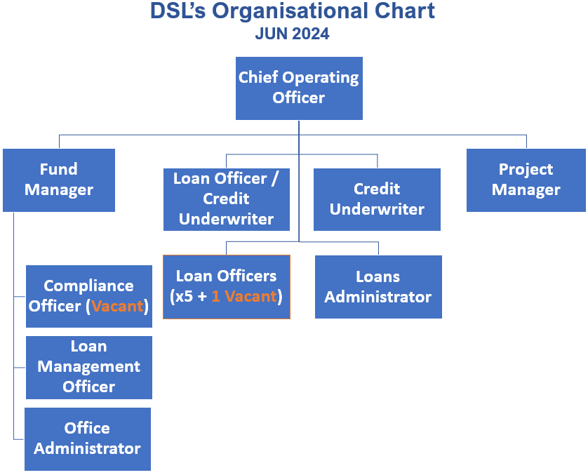
Job context:
DSL Business Finance is Scotland’s leading not-for-profit lender providing access to loan finance for SMEs. Any profits made by the organisation are re-invested for lending rather than being distributed amongst shareholders. In addition to our lending activities, we also manage funds for other organisations. Our business has grown steadily in recent times with several funds being delivered in the past 5 years. This has generated £23m of loans to 737 businesses.

DSL is the Regional Business Support Partner (BSP) for Scotland of the Start Up Loan Company delivering loans throughout in Scotland. We aim to ensure that anyone wanting to start a business can do so, regardless of their economic or social background.

Our objectives are to create opportunities for enterprise; grow existing businesses, create jobs and strengthen the sustainability of local communities.

Job purpose:
The Loan Officer is responsible for engaging with loan applicants to submit proposals for loans to underwriting. The post holder will also work to develop partnerships with local business support agencies, generate their own new leads and ensure DSL services are promoted in the market.
Assignment and review of work:
Duties are determined by the Chief Operating Officer. There will be an annual appraisal with interim reviews of objectives as well as ongoing informal meetings as required in line with normal business practice. Priorities are set in line with business needs.
Key result areas (5-10 statements):
The role will include, but not be limited to, the following: -

Loan Officer Activities
- General administration and appraisal of client applications for all relevant funds.
- Dealing with enquiries, signposting.
- Actively managing work in progress and maintaining good communications with applicants.
- Liaising with intermediary advisers to assist processing of loan applications.

Development/Support Activities
- Supporting clients who wish to make an application with advice and information.
- Making presentations through partner organisations to potential new clients.
- Assisting the DSL team to develop new services for clients and be part of implementing these.
- Working with external advisers to ensure DSL services meet the changing needs of clients and of the organisations that assist those clients.
- Referring clients to other agencies where further help is required.
- Actively seeking new opportunities to win and convert loans for new clients.

Corporate Activities
- Assisting with the organisation of DSL client and partner events.
- Representing the company at relevant events.

Responsibility for resources (direct or indirect):

Number of people: N/A
Budgets: N/A
Finance: N/A
IT: Using and updating systems and processes as appropriate.

Communications and working relationships (internal and external):

Internal
Chief Operating Officer, DSL Team | Assignment and progression of work.

External
Clients, Professionals, Business Advisers and Other funding organisations | Provision and exchange of information to promote the various loan funds.

Job requirements (qualifications, skills, and experience - for job, not of specific job holder):

Essential
- Personally organised, diligent with an eye for and attention to detail.
- Excellent communicator both verbal and written.
- Ability to work independently and as part of a team.
- Ability to take initiative as circumstances require.
- Desire to learn and gain new skills.

Desirable
- Business Plan assessment skills
- Financial qualification/experience
- 3 year’s general business experience
- Minimum 2 years lending experience to SMEs
- Car owner/clean licence
- Experience of working as part of team in a fast-paced environment

Signature of postholder: | Date:
Signature of manager: | Date:
Job description compiled by:  Iain Burnside | Date completed/revised: Jun 2024

