DSL – JOB DESCRIPTION
Job title: CREDIT UNDERWRITER
Salary: £30k to £35k depending upon experience
Reports to: Chief Operating Officer
Organisation chart (reporting lines above and below this job):

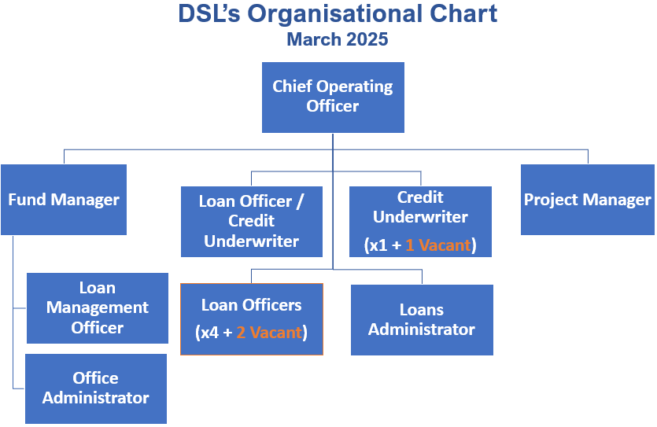
Job context:
DSL Business Finance is Scotland’s leading not-for-profit lender, providing vital loan finance to SMEs. Over the past five years, we have delivered over £19 million in loans to 637 businesses, creating and sustaining 3,793 jobs across Scotland.

We provide and manage a range of loan funds, including microfinance loans of up to £25,000 and smaller loans between £25,000 and £100,000 to support start-up, early-stage, and growing businesses across Scotland, offering financial support at key stages of their development. Delivering these loans successfully requires a good understanding of loan products, risk management, and the needs of businesses at different stages of growth.

Our objectives are to create opportunities for enterprise, grow existing businesses, create job, and contribute to the long-term sustainability of local communities across Scotland

As a responsible lender authorised and regulated by the Financial Conduct Authority (FCA), DSL is committed to upholding the highest standards of conduct, transparency, and integrity in financial services. All roles will involve operating in line with FCA regulatory requirements, including but not limited to Treating Customers Fairly (TCF), data protection, anti-money laundering (AML), know your customer (KYC), and financial crime prevention.

Job purpose:
The Credit Underwriter is responsible for reviewing and assessing loan applications submitted by the Loan Officer team, and ensuring applications received comply with scheme rules and are within policy when making credit decisions.

The post holder will ensure all internal and external risk/compliance protocols are followed and maintained, preparing accurate and concise assessments that provide a clear indication of the decision-making process to achieve a ‘right first time’ outcome.

Assignment and review of work:
Duties are determined by the Chief Operating Officer. There will be an annual appraisal with interim reviews of objectives as well as ongoing informal meetings as required in line with normal business practice. Priorities are set in line with business needs.

Key result areas (5-10 statements):

The role will include, but not be limited to, the following: -

As a Credit Underwriter you will be expected to: -
- Appraise Loan Officer applications submitted on behalf of clients seeking loans, undertaking affordability and viability analysis based on various financial and non-financial information to assess lending risk.
- Deliver timely credit decisions within documented credit policies and own underwriting authority, providing commercially sound recommendations, balancing risk, and supporting customer requirements.
- Assist with the day-to-day credit management and decision-making process.
- Work with other areas of the Business to ensure correct lending decisions and fair outcomes for customers.
- Deliver operational effectiveness and excellence within the business, achieving agreed KPI targets and objectives.
- Ensure strong lines of communication with all areas of the business are maintained and assist the team in achieving SLA’s.

Development/Support Activities will include: -
- Assisting and supporting the DSL team to deliver lending upskilling where appropriate.
- Developing relationships with funding partners to ensure any changes in lending policies/risk protocols/new initiatives are understood and delivered to the DSL team in a timely manner.
- Attending new funding launches and similar events as apt for the role.
- Identifying improvements to policy and procedures.
- Signposting other agencies to Loan Officers where further client help is required.

Corporate Activities will include: -
- Assisting with the organisation of DSL client and partner events.
- Representing the company at relevant events.

Responsibility for resources (direct or indirect):
Number of people: N/A
Budgets: N/A
Finance: N/A
IT: Using and updating systems and processes as appropriate.
Communications and working relationships (internal and external):

Internal
Chief Operating Officer, DSL Team | Assignment and progression of work.

External
Professionals, Business Advisers and Other funding organisations | Provision and exchange of information to promote the various loan funds.

Job requirements (qualifications, skills, and experience - for job, not of specific job holder):

Essential
- Personally organised, diligent with an eye for attention to detail.
- An understanding of the SME market
- Strong analytical skills with ability to document findings and make recommendations.
- Excellent communicator both verbal and written.
- Ability to work independently and as part of a team being able to take initiative as circumstances require.
- Competent IT Skills.

Desirable
- Business Plan assessment skills
- Financial qualification/experience
- 3 year’s general business experience
- Minimum 2 years lending experience to SMEs
- Car owner/clean licence
- Experience of working as part of team in a fast-paced environment

Signature of postholder: | Date:
Signature of manager: | Date:
Job description compiled by:  I A Burnside | Date completed/revised: March 2025

