DSL – JOB DESCRIPTION
Job title: LOAN OFFICER
Salary: £25k to £32k depending upon experience
Reports to: SENIOR LOAN OFFICER
Organisation chart (reporting lines above and below this job):
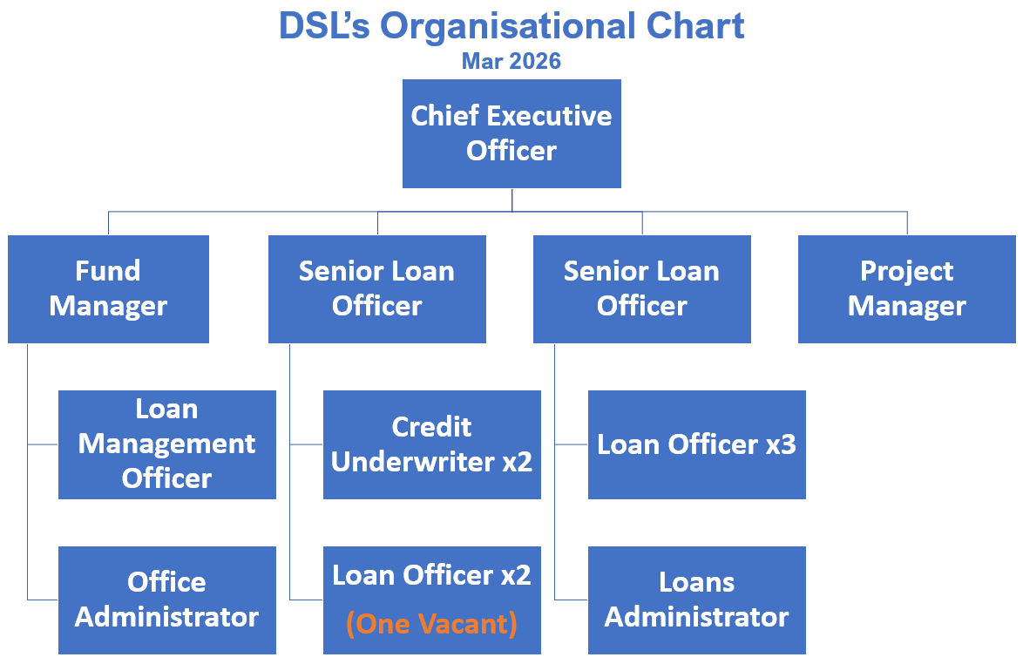
Job context:
DSL Business Finance is Scotland’s leading not-for-profit lender, providing vital loan finance to SMEs. Over the past five years, we have delivered over £15 million in loans to about 500 businesses, creating and sustaining 3,000 jobs across Scotland.

We provide and manage a range of loan funds, including microfinance loans of up to £25,000 and smaller loans between £25,000 and £100,000 to support start-up, early-stage, and growing businesses across Scotland, offering financial support at key stages of their development. Delivering these loans successfully requires a good understanding of loan products, risk management, and the needs of businesses at different stages of growth.

Our objectives are to create opportunities for enterprise, grow existing businesses, create job, and contribute to the long-term sustainability of local communities across Scotland.

As a responsible lender authorised and regulated by the Financial Conduct Authority (FCA), DSL is committed to upholding the highest standards of conduct, transparency, and integrity in financial services. All roles will involve operating in line with FCA regulatory requirements, including but not limited to Treating Customers Fairly (TCF), data protection, anti-money laundering (AML), know your customer (KYC), and financial crime prevention.

Job purpose:
The Loan Officer is responsible for engaging with loan applicants of the Investment Fund for Scotland (IFS) to submit proposals for loans to underwriting, ensuring these align with our lending criteria. The post holder will also work to develop partnerships with local business support agencies, generate their own new leads, and ensure DSL services are promoted in the market, growing brand awareness.
Assignment and review of work:
Duties are determined by the Senior Loan Officer. There will be an annual appraisal with interim reviews of objectives as well as ongoing informal meetings as required in line with normal business practice. Priorities are set in line with business needs.

Key result areas (5-10 statements):
The role will include, but not be limited to, the following: -

Loan Officer Activities
- General administration and appraisal of client applications for all relevant funds.
- Dealing with enquiries, signposting.
- Actively managing work in progress and maintaining good communications with applicants.
- Liaising with intermediary advisers to assist processing of loan applications.

Development/Support Activities
- Supporting clients who wish to make an application with advice and information.
- Making presentations through partner organisations to potential new clients.
- Assisting the DSL team to develop new services for clients and be part of implementing these.
- Working with external advisers to ensure DSL services meet the changing needs of clients and of the organisations that assist those clients.
- Referring clients to other agencies where further help is required.
- Actively seeking new opportunities to win and convert loans for new clients.

Corporate Activities
- Assisting with the organisation of DSL client and partner events.
- Representing the company at relevant events.

Responsibility for resources (direct or indirect):

Number of people: N/A
Budgets: N/A
Finance: N/A
IT: Using and updating systems and processes as appropriate.

Communications and working relationships (internal and external):

Internal
Senior Loan Officer, DSL Team | Assignment and progression of work.

External
Clients, Professionals, Business Advisers and Other funding organisations | Provision and exchange of information to promote the various loan funds.

Job requirements (qualifications, skills, and experience - for job, not of specific job holder):

Essential
- Personally organised, diligent with an eye for and attention to detail.
- Excellent communicator both verbal and written.
- Ability to work independently and as part of a team.
- Ability to take initiative as circumstances require.
- Desire to learn and gain new skills.
- Business Plan assessment skills
- Minimum 2 years lending experience to SMEs

Desirable
- Financial qualification/experience
- 3 year’s general business experience
- Car owner/clean licence
- Experience of working as part of team in a fast-paced environment

Signature of postholder: | Date:
Signature of manager: | Date:
Job description compiled by:  I A Burnside | Date completed/revised: Mar 2026

